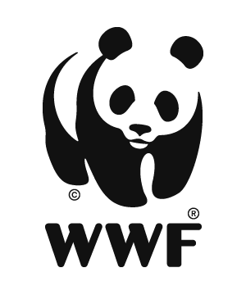
WWF GEF Agency
Six Month Project Progress Report

Title (GEF ID): Managing Watersheds for Enhanced Resilience of Communities to Climate Change in Nepal (MaWRiN) Project (10727)

Project Report information:
Report Author(s) | Nabin Dhungana, PhD
Report Completion Date | Jan 31, 2026
Reporting Period | July 1 – Dec 31, 2025

1. General  Information | Agency Approval Date | Jun 16, 2023
1. General  Information | Fiscal Year | 2026
2. Budget | Total Project Budget | US $ 9,024,312 (LDCF)
2. Budget | Total GEF disbursement (USD) through June 30 of the FY for project that has been in implementation for at least 1 FY | US $ 1,707,110.84
2. Budget | Materialized Co-finance | NA

Project Contact information:
Project Position | Name | E-mail
Technical Team Leader | Nabin Dhungana, PhD | nabin.dhungana@wwfnepal.org
Project Officer | Bishnu Bhusal | bishnu.bhusal@wwfnepal.org
MEL & Communication Officer | Sanu Thapa | sanu.thapa@wwfnepal.org
Finance & Compliance Officer (FCO) | Bijendra Sah | bijendra.sah@wwfnepal.org
Project Engineer | Amar Kumar Sah | amar.sah@wwfnepal.org
Project Associate | Nisha Silwal | nisha.silwal@wwfnepal.org
Project Associate | Praful Singh | praful.singh@wwfnepal.org

Outcomes and Impacts Achieved
Component 1: Enabling environment for mainstreaming climate change, through the development of capacity of the municipalities and other key local agencies to assess and understand climate risks and vulnerabilities, and accordingly mainstream climate change adaptation strategies and actions in local plans and policies, and the establishment of a multi-stakeholder platform for dialogue and cooperation on climate change adaptation at the watershed level.

Outcome 1.1: Improved understanding, knowledge and capacity to mainstream climate change adaptation in local plans and policies

To improve understanding, knowledge, and capacity to mainstream climate change adaptation into local plans, and policies, the project complected learning and exchange visit to government agencies, initiated consultants engaging process for assessment and studies, and the preparatory work for implementing FY2026 activities and budget.

The learning and exchange visit of the Province Secretary, Ministry of Forests and Environment, Bagamati Province; Chief, Soil and Watershed Management Office, Ramechhap; and the Technical Team Leader of the MaWRiN Project was successfully completed through participation in COP30, the UN Climate Change Conference, held in Belém, Brazil, from 17 to 26 November 2025. The visit aimed to strengthen policy and practical understanding of international climate commitments, adaptation financing, and governance approaches relevant to Nepal’s federal and provincial priorities, particularly in mainstreaming climate change adaptation in watershed management, water security, and community resilience in line with MaWRiN Project objectives.

During COP30, the team participated in plenary sessions, high-level dialogues, and selected technical and thematic side events focused on climate adaptation, the Global Goal on Adaptation, and adaptation finance for building resilience of vulnerable communities. These sessions emphasized translating global climate commitments into actionable national and sub-national interventions. The team engaged with representatives from national governments, multilateral agencies, development partners, and climate experts, with particular focus on policy coherence, institutional coordination, and integration of climate resilience into development planning. Special attention was given to experiences and financing models applicable to mountainous and climate-vulnerable countries such as Nepal. Overall, participation in COP30 was highly relevant and beneficial for strengthening strategic and policy-level engagement at provincial and local level agencies in climate-resilient water and watershed management. The insights gained will support improved guidance, coordination, and implementation of climate-responsive interventions under the MaWRiN Project and strengthen informed policy leadership within the Ministry of Forests and Environment at the provincial level.

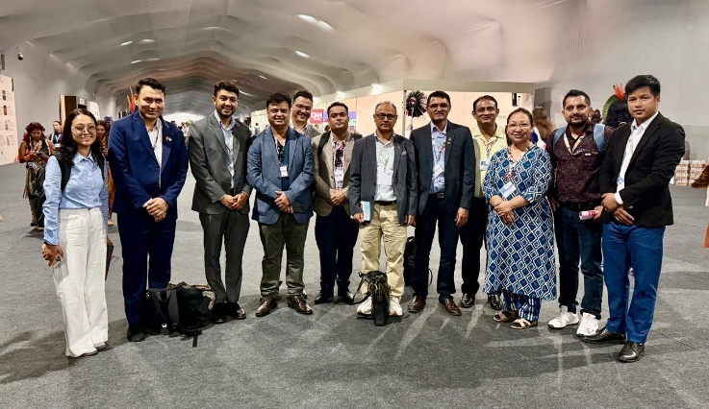 | 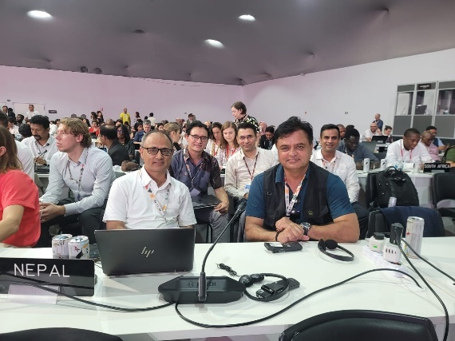
Figure 1: Nepali delegates in COP30 | Figure 2: Province Secretary, Ministry of Forests and Environment, Bagamati Province and Climate Change Management Division (CCMD) chief participating in high level climate negotiat
The project supported the Forest Research and Training Centre (FRTC), under the Ministry of Forests and Environment, Bagmati Province, to organize the Provincial Conference of Forest and Environment Experts. The conference brought together 131 participants, including 19 Women, 28 Indigenous (Janajati), 4 Dalit, and 17 Youth from government agencies, civil society, technical experts, media, and development partners to review progress, strengthen coordination, share best practices, learning and identify gaps in forestry, climate change adaptation, watershed management, and sustainable forest management.
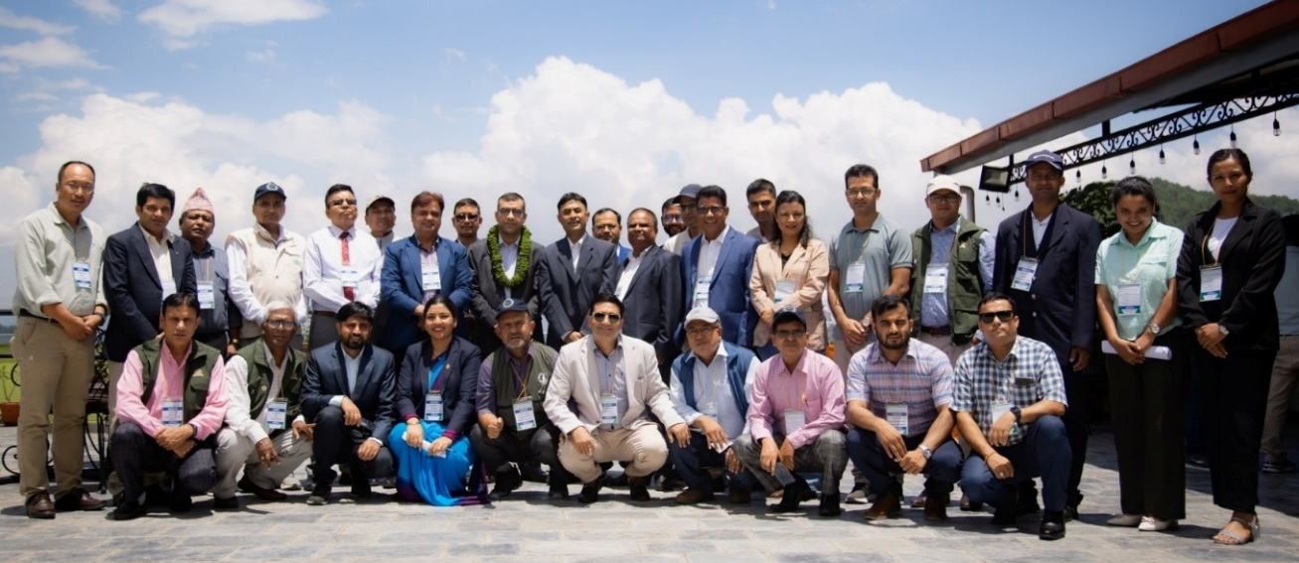
Figure 3: Participants of Provincial Conference of Forest and Environment Experts
The conference featured three thematic technical sessions on forestry sector planning, climate change and watershed management, and the feasibility and implementation of sustainable forest management guidelines in Bagmati Province. Key outcomes included strengthened inter-institutional coordination, agreement to integrate/mainstream climate change adaptation into planning, commitment to annual sector review mechanisms, and preparation of a follow-up action plan. The event generated 14 strategic recommendations related to participatory planning, climate change adaptation, integrated watershed management, sustainable forest management (SFM) guideline revision and scaling, capacity building, policy updates, eco-tourism promotion, and multi-sectoral collaboration, reaffirming alignment with the MaWRiN Project priorities.

Project initiated processes to conduct two studies focused on: (i) Activity 1.1.2.1- reviewing municipal plans and policies of key sectors to identify gaps and to integrate climate adaptive aspect in policy and budget, and (ii) Activity 1.1.3.1- defining the structure, functions, and operational framework for establishing a multi-stakeholder platform at the watershed level. Following the finalization of the Terms of Reference (ToR), the publication of the call for applications/roster will be initiated by Soil and Watershed Management Office (SWMO), Ramechhap. In addition, preparatory activities including the finalization of concept notes and training/workshop content, identification of potential resource persons, and coordination with relevant stakeholders are currently ongoing. During the reporting period, a total of 160 individuals participated in these activities. This included 28 Women, 50 Indigenous (Janajati), 7 Dalit, and 30 Youth.

Component 2: Enhanced Resilience of Local Communities to Climate Change through a) community-based natural resource management such as community identification of adaptation interventions, support and demonstration of sustainable and climate-resilient agriculture and livestock practices, improved water management, strengthened management of community and leasehold forests, and b) Nature-based solutions that reduce climate impacts and risks.

Outcome 2.1: Increased adaptive capacity of vulnerable households in the Marin Watershed to climate-induced disasters such as landslides, floods

To increase the adaptive capacity of vulnerable households in the Marin Watershed to climate-induced disasters such as landslides, floods, drought the project-initiated processes to conduct study on identifying climate-adaptive and gender-responsive tools and technologies (Activity 2.1.1.4), supported identification of potential farmers and technical field verification of 134 households for shed improvement, 5 households for commercial farming, 1 site for water source restoration, 5 sites for bioengineering (including small-scale physical infrastructure works and biological components), 5 sites for well construction, 1 site for sub-surface water harvesting, 6 sites for conservation pond construction, and 11 sites for check dam construction. The process is currently underway to finalize the agreements. In addition, safeguards screening of the potential selected activities, preparation of designs and estimates, concept notes and training schedules, as well as the selection of households for resilience seed support and households and groups for improved breed support, is currently ongoing.
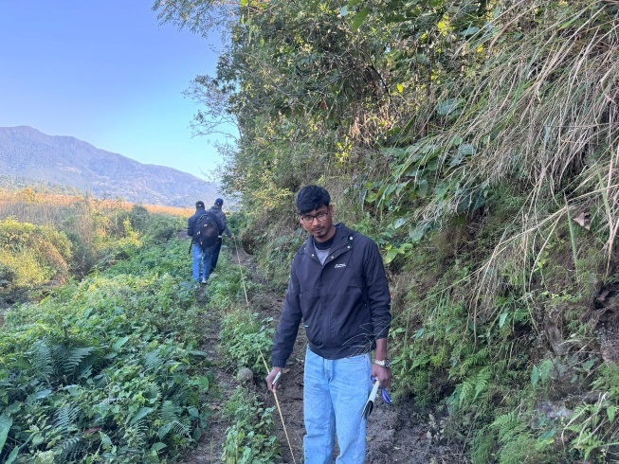 | 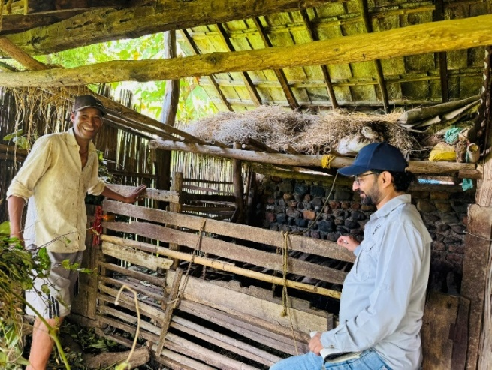
Figure 4: Dimension measurement and technical verification of the selected activities/sites

Outcome 2.2: Nature-based solutions (NbS) reduce climate-induced vulnerabilities of community livelihood resources and assets.
As part of identifying and promoting nature-based solutions (NbS) with focus to climate-adaptive, watershed and forest management, and climate-smart agriculture practices, a public notice has been published to support students and academic institutions through thesis and research grants for bachelor and master students (Activity 2.2.1.7). In addition, covering the activities across all the outcome areas safeguards screening process is ongoing for the proposed activities of FY2026 following the Environmental and Social Management Framework (ESMF) to identify and manage potential risks and impacts of the identified activities. The screening covered activities such as bioengineering, shed improvement, water source restoration, commercial vegetable production, sub-surface water harvesting, irrigation canal system, check dams, and conservation ponds etc. During the reporting period, a total of 78 individuals participated in these activities. This included 44 Women, 62 Indigenous (Janajati), 3 Dalit, and 48 Youth.

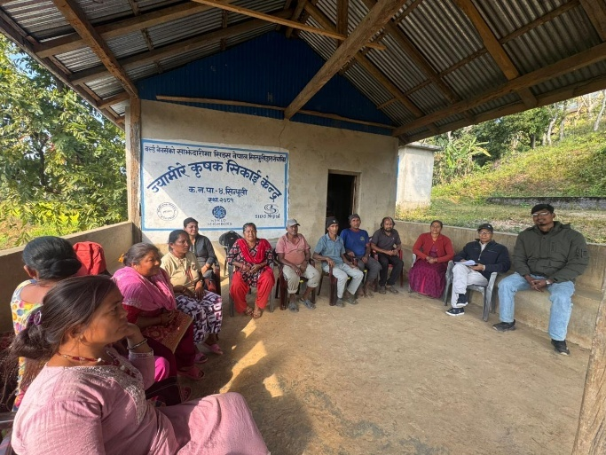 | 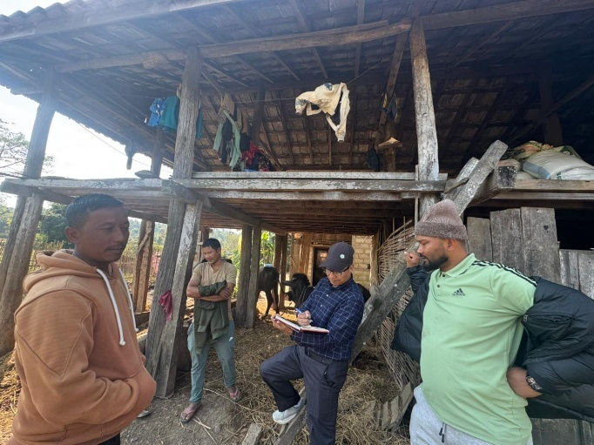
Figure 5: Safeguards and GESI experts conducting focus group discussions and safeguards screening for the proposed activities

Component 3: Monitoring, evaluation and knowledge management, through tracking of project progress on a regular basis, garnering and analysis of lessons and good practices, and development and dissemination of knowledge that reinforces project results from components 1 and 2, providing sound basis for their replication, adaptation and sustainability.

Outcome 3.1: Project monitoring, evaluation, and learning to enable adaptive management, replication and sustainability.

To strengthen project monitoring, evaluation, and learning for adaptive management, replication, and sustainability, key milestones achieved during this reporting period include successful organization task force meeting for finalization of the Program Implementation guideline (PIG), Activities and Budget Entry in Provincial Line Budget Information System (PLMBIS), Provincial Conference of Forest and Environment Experts, consultancy procurement to assess and document climate-resilient indigenous knowledge and practices, Project Coordination Committee (PCC) and Cost Center Orientation on FY 26 AWP&B, and Continuous Operation and Maintenance of MaWRiN Project website.

A high-level institutional mechanism, the Project Steering Committee, established a five-member task force to finalize the Project Implementation Guideline (PIG) for implementation of the AWP&B of FY26. As a result, the PIG was approved on 26 September 2025 and officially published (https://mofe.bagamati.gov.np/content/454/watershed-management-for-enhancing-community-resilience-to/). It was then shared with the three cost centers Division Forest Office, Sindhuli; Division Forest Office, Marin; and the Soil and Watershed Management Office, Ramechhap to ensure effective implementation of AWP&B in compliance with Government of Nepal and GEF requirements. In addition, the activities and budget entry in the PLMBIS was complected on 13 November 2025.

The project has initiated the consultancy procurement process, which is currently ongoing. The objective of the consultancy (Activity 3.1.1.2) is to assess and document indigenous knowledge on climate resilient methods and practices in the project area and to promote their integration into the design of climate adaptive solutions for agriculture, livestock management, water management, community and leasehold forest management, and climate disaster risk reduction. Following the finalization of the Terms of Reference (ToR), the Soil and Watershed Management Office, Ramechhap will publish the call for applications or roster.

At the project working area level, a Project Coordination Committee (PCC) chaired by the Chief of the District Coordination Committee (DCC), Sindhuli, was established to coordinate, review, and monitor field-level project activities. A PCC meeting (Activity 3.1.2.4) combined with joint field monitoring was successfully conducted on 12 November 2025. The meeting focused on reviewing the progress of the FY 2025 Annual Work Plan and Budget (AWP&B) through field monitoring and interactions with primary beneficiaries, as well as discussing and endorsing the approved plan and budget for FY 2026. The PCC provided key feedback and recommendations to further strengthen FY 2025 activities, including the need for regular monitoring and enhanced capacity building of beneficiaries to ensure the sustainability of supported interventions. Specific suggestions included strengthening the technical capacity of fishpond beneficiaries in fish farming practices and initiating a water tariff system to establish a basket fund for routine operation and maintenance of water supply schemes. The meeting formally endorsed FY 2026 AWP&B for implementation.
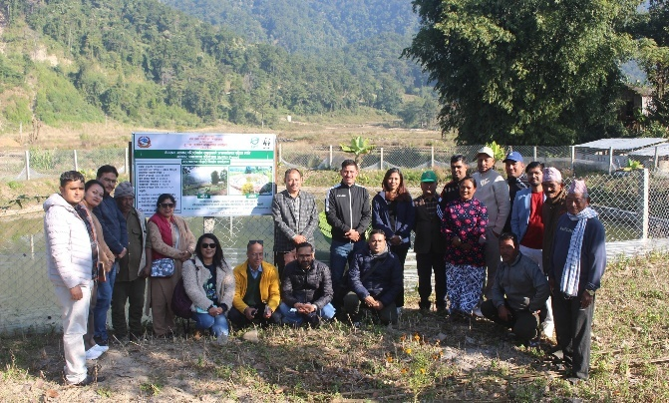 | 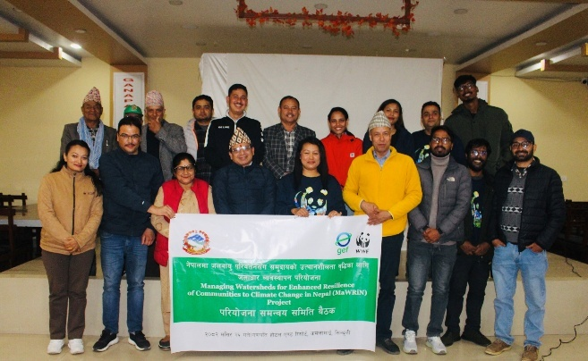
Figure 6: Project Coordination Committee (PCC) meeting cum joint monitoring visit
The participatory discussions and field monitoring visits enhanced coordination and collaboration among stakeholders, supported evidence-based feedback, and contributed to a shared understanding of project priorities. A total of 15 officials and representatives from municipalities and rural municipalities, the Division Forest Office, the Agriculture Knowledge Centre, the Livestock Support Expert Service, the Soil and Watershed Management Office, and other relevant institutions participated in the meeting.

Two Cost Centre Orientation events were conducted for Division Forest Office (DFO), Marin on 21 December and DFO, Sindhuli on 24 December 2025. The orientations aimed to establish a common understanding among cost centres by providing comprehensive guidance on financial and programmatic management, safeguards (Social and environmental), Gender action plan, mainstreaming poor, vulnerable, indigenous communities in programming, compliance, project processes and procedures, and the roles and responsibilities of cost centres.

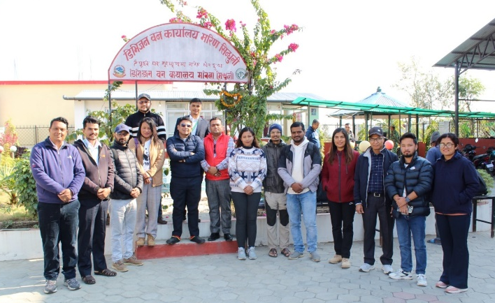 | 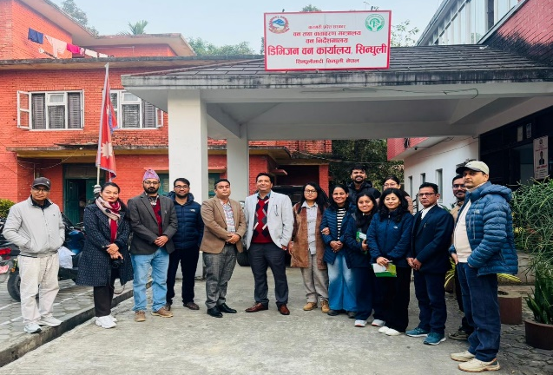
Figure 7: Cost centre Orientation (DFO, Marin) | Figure 8: Cost centre Orientation (DFO, Sindhuli)

The orientations (which included information on Safeguards and gender requirements) helped build a shared understanding of implementation requirements and expectations. At the end of each orientation, the respective cost centre developed an action plan for the timely execution of approved activities and budgets. A total of 27 officials and representatives from DFO Marin and DFO Sindhuli participated in the orientations and committed to implementing the agreed activities and budgets as discussed and decided during the orientations.

In addition, the Project Management Unit conducted regular monitoring and coordination visits to MaWRiN project sites and engaged with beneficiaries, local governments, Division Forest Offices, the Agriculture Knowledge Centre, the Livestock Support Expert Service, and the Soil and Watershed Management Office to promote sustainability and local ownership.

Stakeholders demonstrated a high level of ownership of activities implemented in FY 2025 and planned for FY 2026, particularly in agriculture, livestock, fisheries, and nursery management. Key actions identified during the visits included strengthening coordination with local governments and ward chairpersons, initiating nursery strengthening activities in a timely manner with a focus on bio-engineering species such as bamboo (Bambusa vulgaris) and vetiver (Chrysopogon zizanioides), and improving nursery irrigation and fencing.
Overall, the monitoring visits and coordination meetings strengthened partnerships and laid a strong foundation for effective and efficient project implementation.
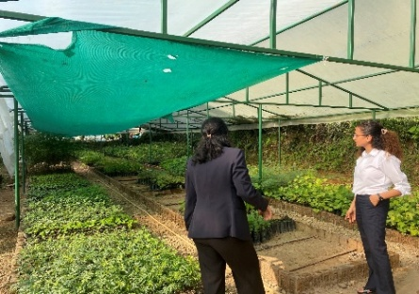 | 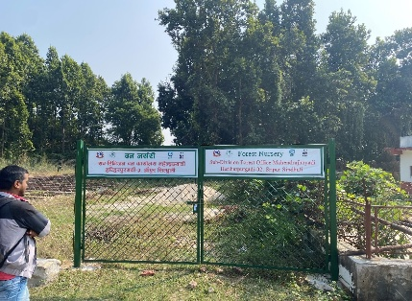 | 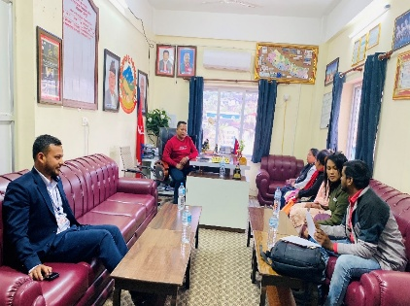
Figure 9: Monitoring visit and coordination meeting with key stakeholders and key sites

Summary of Major Challenges and Strengths
Challenges:
- Delay on budget on treasury fund release process: The release of grant assistance (on-budget, on-treasury) was significantly delayed. The required activity approval and budget entry in the Provincial Line Ministries Budget Information System, which started in May 2025, was only completed on 13 November 2025. Because of this delay, the Financial Comptroller General Office was unable to release funds earlier. Fund disbursement to the concerned cost centers namely the Division Forest Office Marin, Division Forest Office Sindhuli, and the Soil and Watershed Management Office Ramechhap only began after this completion and is still ongoing.
- Prioritization of working area: Out of the 10 sub-watersheds identified under the project, only 6 have been prioritized for intervention, even though all were assessed as vulnerable to climate risks and livelihood insecurities as per the field observation, suggested by local government and Project Coordination Committee (PCC) members. Local government representatives, particularly politically elected leaders, have visited the PMU office and urged the project team to also implement activities in the remaining 4 sub-watersheds even in the PCC meeting. The team is resolving this challenge in the leadership of the PCC.
- Insufficient understanding: Local governments and communities lack awareness of watershed management and climate adaptation which has limited the effective engagement of local government specifically in Ghyanglekh Rural Municipality there by hindering project integrated focused on the priority sub-watersheds.
- Women participation: Women’s participation in project activities were lower than expected in the project document, indicating the need for more inclusive strategies to ensure their meaningful engagement in planning and decision-making processes.More information is provided in Section D.
- Management cost for cost centres: From FY 2026, the number of cost centres has expanded from one to three. However, the existing six-year AWP and Budget does not include provisions for additional project management and administrative costs required to manage these cost centres.

Strengths:
- Government ownership: Majority of activities are on-budget on treasury, with multi-stakeholder engagement in activities planning, implementation and monitoring through PSC, PCC, joint monitoring enhances the ownership.
- Community-driven activities: Component 2 focuses on hardware interventions preferred by communities.
- Indigenous community engagement: High collaboration with IPs, who form the majority in the watershed.
- Bottom-up planning: Institutionalized Sub-Watershed Coordination Committees which are formed representing community stakeholders (such as farmers groups, Community Forest User Groups, women groups, IPs, Federation of Community Forestry Users and so on) within sub watershed for participatory planning.
- Institutional and technical capacity: With the extension of two cost centers to the Divisional Forest Offices of Sindhuli and Marin, the project is expected to leverage their existing technical and institutional capacities for implementing forest management activities and utilizing allocated budgets. This will enhance implementation effectiveness and ensure the quality and long-term sustainability of the proposed interventions.
- Engagement in policy discourse: The project actively engages in local government policy processes through policy reviews and the identification and sharing of policy gaps. This creates opportunities to mainstream and integrate climate change adaptation and watershed management priorities into local government planning and budgeting processes.

Progress, Challenges, and Outcomes of Stakeholder Engagement

(Based on Stakeholder Engagement Plan (SEP) or equivalent included in the ProDoc)
The progress and outcome made as per stakeholder engagement plan are mentioned below with details of stakeholders engaged across different tiers and their respective contributions to various project activities:
Tiers/Level | Stakeholders Name | Expected mode of engagement (As mentioned in ProDoc) | Year 1 Progress
Tiers/Level | Stakeholders Name | Expected mode of engagement (As mentioned in ProDoc) | Project Activity | Mode of Engagement
Federal | Ministry of Forest and Environment (MoFE), Ministry of Finance (MoF), Financial Comptroller General Office, Kathmandu, Nepal | - Policy level, programmatic guidance and technical backstopping.  - Advisory role related to AWP&B and entry in LMBIS.  - Support in the fund release process | - AWP&B finalization, entry in P/LMBIS, and fund release process | - Facilitated to finalize AWP&B and entry in L/PMBIS.  - Technical guidance and facilitation in the fund release process
Province | - Ministry of Forest and Environment (MoFE) Bagmati Province and Ministry of Economic Affairs and Planning, Hetauda, Makwanpu | - Strategic guidance and enabling environment for the effective implementation  - PSC oversees for PMU for the overall project implementation  - Approval of AWP&B, procurement plan and Program implementation guideline (PIG) | - Approval of Program implementation guideline (PIG) | - Approved Program implementation guideline (PIG)  - Create enabling environment to prepare AWP&B and PLIMBIS entry
District Level | District Coordination Committee (DCC), Division Forest Office Sindhuli, Division Forest Office Marin, Agriculture Development Office (ADO), Livestock Service office, Nepal, Soil and Watershed Management Office, Ramechhap | - Coordinate, review, monitor field level activities and facilitate wider stakeholder engagement  - Technical backstopping and monitoring relevant to the affairs of their respective theme | - Project Coordination Committee meeting  - Joint monitoring | - PCC members at PCC meeting: Reviewing the progress of the FY 2025 Annual Work Plan and Budget (AWP&B) through field monitoring and interactions with primary beneficiaries, as well as discussing and endorsing the approved plan and budget for FY 2026.  - Committed to support and to create enabling environment to implement project.  - Cost centre orientation to Division Forest Office (DFO) Sindhuli and Marin.  - Feedback, suggestion and share experience to planning FY2027 activities and budget.
R/Municipality Level/ Local Government Ward Office | Kamalamai Municipality, Ghyanglekh RM, Marin RM, Hariharpurgadi RM, Ward Chairperson, Sub-division Forest Office Kapilakot, Sub-Division Forest office Hariharpurgad, Sub-division Office Ghyanglekh | - Facilitation, coordination and monitoring | - Joint monitoring and Sub-watershed level planning | - Engage in site identification to implement FY2026 activities, planning, Implementation and monitoring process.  - Sub-divisional forest offices were engaged in cost centre orientations
Community Based organization (CBOs) including sub-watershed level | Sub-watershed level committee (Simale, Dhungajor, Gaghar, Phulbari, Kyan and Jalkeni-Sakhauri), CFUGs (Aapjhori, Tribeni, Namobudhha, Siddhartha, Simkaali, Pathraahi, Darbardaanda, Ekta Saamari, Himal, Janhit, Jankalyan, Lohasur, Shikhar, Jankalyan, Saalghari, Jalewa Adharsa, Betjhori and Laligurans), LFUGs (Kalika Devi, Laangdi, Jugepaani, Bhirgaaun Amale, Devkhola and Kuwapaani), Women’s Group (Makhmali Women), Farmer’s Group (Makhmali) and Water and sanitation Group (Betyani Khanepani) | - Direct implementation community level activities  - Facilitation, coordination and monitoring  - Household and site identification to implement project activities | - Sub-watershed level planning  - Facilitation for identification of sites for implementing FY 2026 AWP&B | - Identification of site for implementing community level activities  - Sustainable use management project supported activities and resources
The major challenge during this reporting period was ensuring proactive engagement from the provincial and federal Ministry of Forests and Environment and the Ministry of Finance in the LMBIS and PLMBIS processes for activity and budget entry. Unclear delineation of roles and responsibilities between MoFE and MoF regarding federal conditional grants, particularly on who should enter detailed activities and budgets in PLMBIS, delayed timely engagement and slowed the process.

Information on Progress on Gender-Responsive Measures

(As documented at CEO Endorsement in the Gender Action Plan or Equivalent)
As recommended by the Gender Action Plan (GAP), the safeguards screening of FY2026 activities engaged women and vulnerable groups through focus group discussions. A total of 78 individuals participated, including 79% Indigenous peoples (Janajati), 56% Women, 9% Dalit, and 62% Youth. The screening confirmed that the proposed activities pose no potential negative impacts on women or vulnerable groups and are designed to benefit them, as validated through consultations with these groups.
In addition, sub-watershed level coordination committee meetings engaged 26 individuals, including 85% Indigenous peoples (Janajati), 35% Women, 12% Dalit, and 46% Youth. These meetings identified Indigenous (Janajati) households, women-headed households, and other vulnerable households, as well as their priority needs, to ensure that project interventions support their inclusion, share benefit and capacity development.
Furthermore, various capacity-building activities such as meetings, conferences, learning and exchange visits, and orientations for government agencies engaged 176 individuals, including 20% Indigenous peoples (Janajati), 18% Women, 3% Dalit, and 26% Youth. These activities involved municipalities, rural municipalities, government staff, elected representatives, women, and Indigenous peoples to strengthen capacity and engagement. While participation of women and vulnerable groups shows progress against the GAP, women’s representation remains below the 33% target, largely due to male-dominated leadership positions within government agencies.
To strengthen gender mainstreaming and coordination, a female focal point has been designated in Division Forest Office Sindhuli & Marin to liaise with stakeholders and the Project Management Unit (PMU) on project progress and related issues. In addition, there is a mandatory provision in guidelines for the inclusion of at least one female member as one of three-member Grievance Redress Mechanism (GRM) committees, ensuring that gender-related concerns are effectively represented and addressed. In addition, in upcoming Annual Workplan and Budget FY027 includes specific activities aimed at increasing women’s participation. Women’s representation in government leadership positions is relatively low, which contributes to lower participation in activities targeting government agencies.
A key challenge identified at the field level was “time poverty,” as heavy domestic workloads among Indigenous communities frequently conflicted with mid-day discussions schedules. This underscored the need to better align future discussions and engagement activities with women’s availability and time constraints.

Progress, Challenges, and Outcomes of Safeguards

(Based on Environmental and Social Management Framework and any other safeguards documents included at CEO Endorsement)
The project has been effectively implementing environmental and social safeguards screening to identify potential impacts of proposed activities and to minimize adverse effects on communities and the environment. To date, Environmental and Social (E&S) screening has been completed for all 45 sub activities, including check dams, irrigation systems, conservation/fishery ponds, animal sheds, and plastic tunnels. The screening confirmed that the interventions are predominantly Category C or low risk, as they are manually implemented within existing streambeds or banks or on private land, without land acquisition or forest clearing.

The screening process applied a mixed methodology, including key informant interviews, focus group discussions, community meetings, and direct site observations. A total of 78 community members and stakeholders were engaged, including 44 Women, 62 Indigenous (Janajati), 7 Dalit, and 48 Youth. Discussions were structured around 42 guiding questions covering seven thematic areas: environmental impacts, socio economic impacts, labor and working conditions, minorities and vulnerable groups, occupational and community health and safety, GBV and SEAH risks, and conflict sensitivity and risks.

Among the 45 sub activities, only one sub project i.e. restoration and protection of water sources required Free, Prior, and Informed Consent (FPIC), which was completed successfully. The remaining activities did not require FPIC, as they posed no adverse impacts and instead supported livelihoods without affecting Indigenous (Janajati) customary rights. Overall, the screening concluded that separate Indigenous Peoples Plans, Land Resettlement Plans, and Environmental and Social Management Plans are not required, given the absence of land acquisition and adverse impacts on beneficiary farmers.

The project has integrated safeguard clauses, including Free, Prior, and Informed Consent (FPIC), into the Terms of Reference for hiring consulting services. A formal Grievance Redress Mechanism guideline has also been developed, establishing multiple tiers of GRM committees and providing several communication channels, including a website, phone number, and suggestion boxes. The guidelines will be shared with GEF oversight for finalization.

A key challenge during the screening process has been managing multiple sub activities and ensuring effective safeguards monitoring across geographically dispersed sites.

Knowledge Activities / Products

(When Applicable, as Outlined in Knowledge Management approved at CEO Endorsement)
Based on the knowledge management and communications plan as approved at CEO endorsement, the project has made the following progress:

Project Website: A consulting service has been hired for the annual maintenance of the project website, which disseminates knowledge and communication products generated by the project. The website presents project information in Nepali, Tamang (the primary language of Indigenous Peoples in the project area), and English, and includes a platform for submitting grievances. It is accessible at https://mawrin.bagamati.gov.np/ and has been visited by 55 users to date.

Project Implementation Guideline (PIG): The Project Steering Committee established a five-member task force to finalize the Project Implementation Guideline for implementing the FY26 Annual Work Plan and Budget. The PIG was approved on 26 September 2026 and officially published https://mofe.bagamati.gov.np/content/454/watershed-management-for-enhancing-community-resilience-to/.

Social Media: The MaWRiN Project maintains a Facebook page titled "MaWRiN Project," which has over 289 followers. Additionally, the “मरिण परियोजना” Facebook account has over 1,500 followers. These platforms have been effective in sharing project updates, engaging stakeholders, and raising awareness about key activities and impacts. The page is available at https://www.facebook.com/profile.php?id=61574294127886.

Grievance Redress Mechanism (GRM) Guideline: The project has developed a GRM guideline to ensure transparent, legitimate, and reliable mechanisms are in place at different levels, allowing affected stakeholders, including local communities and Indigenous Peoples, to raise complaints or grievances and have them addressed in a timely and consistent manner.

Consent Form: A consent form has been developed for PMU staff and consulting firms/individuals to obtain permission from contributors who are the subjects of films, photography, or interviews.

Implementation of Workplan and Budget
The release of Grant Assistance (GA) funds on budget and on treasury, amounting to USD 1,513,718.07, to the three cost centres (SWMO Ramechhap, DFO Marin and DFO Sindhuli) is still in process, and no expenditure progress has been recorded to date. As a result, activities under GA remain at the planning stage. However, the fund release process is expected to be finalized from January 2026, after which field level implementation will begin.

Under the Technical Assistance (TA), which is off budget and off treasury with a total allocation of USD 193,392.77, the project has spent USD 74,639.93 (39%), completing 6 out of 16 planned activity units.
Overall, out of the total project budget of USD 1,707,110.84 (GA+TA), the project has incurred an expenditure of USD 75,340.56, equivalent to 4.41% progress.

Lessons Learned
Expanding Cost Centre: Implementing all thematic activities including climate change, forest management, livestock and agriculture management, and watershed management through a single cost centre (SWMO Ramechhap) in FY2025 constrained operational effectiveness, technical capacity, and budget utilization. Expanding to include DFO Sindhuli and DFO Marin enhanced coordination, resource utilization, and the implementation of forest management interventions.

Activities and Budget Entry in LMBIS: Entering activities and budgets into the PLMBIS consumed nearly the first two quarters of FY2026. Discussions with the Federal MOFE indicate that providing detailed activity and budget information in LMBIS by April–May can eliminate the need for separate PLMBIS entry, enabling activities to start earlier in the first quarter and improving the overall progress, timeliness, and effectiveness of the annual work plan and budget.

Activity Packaging: Monitoring visits showed that activities like fishery pond development are more effective when planned as comprehensive packages rather than focusing only on physical construction. This includes components such as fingerling stocking, community training, greenery development, labor insurance, and safety measures. Such integrated activity planning has been well received by stakeholders and beneficiaries, improving both labor safety and the sustainability of the interventions.

Adaptive Management
Please check all applicable modifications made to the project during this reporting period noting a description of the change, justification for the change and the date of No-Objection given by the WWF GEF Agency. If not applicable, please leave blank. Please see guidance on definitions and procedures for Major and Minor Amendments. Note: it is recommended that all changes be discussed in advance with the GEF Program Manager.

Category of change | Description of the change | Justification | Date of No-Objection by WWF GEF
Major Amendments
☐Project Scope
☐ Project Objective
☐>5% Increase in financing
Minor Amendments
☐ Results framework
☐ Components and cost
☐Institutional and implementation arrangements | Additional two cost center i.e. DFO Sindhuli and DFO Marin were added | Two additional cost centers were added following a decision by MoFE Bagamati Province, based on a proposal from the PCC, with consent from MoFE Kathmandu and discussion with the GEF Oversight. This is expected to improve operational effectiveness, strengthen technical capacity, and enhance budget utilization. | WWF GEF Oversight team member attended the PSC meeting on 8 May 2025, where the PSC decided to add two additional cost centers.
☐Financial management
☐Implementation schedule
☐ Executing Entity
☐Executing Entity Category
☐Minor project objective change
☐ Safeguards
☐ Risk analysis
☐ Increase of GEF project financing up to 5%
☐ Co-financing
☐ Location of project activity
☐ Other: <fill in>
For any proposed or anticipated changes to the project this coming year, please describe below what those changes would be (e.g., in the workplan or results framework) and provide justification. Note: It may be helpful to reference project lessons, challenges, strengths and/or the project theory of change.

