FISHERY POND DEVELOPMENT

FACT SHEET July 2025
District
Sindhuli

User Committee
Simle Khola Machapokhari

Watershed
Marin

Sub-watershed
Simle

Location
Ghyanglekh RM-1, Simle

Key threats and vulnerability
Drying of water sources, water seepage, Risk of Crab, Snake and Frog to fingerling

SNAPSHOT
INTRODUCTION:
Fishery pond development is a key strategy to enhance local livelihoods, improve food and nutritional security, and promote sustainable water use. In rural watersheds of Nepal, collecting rainwater runoff in ponds during the monsoon season helps reduce flood risks while providing a reliable water source for fish farming. As natural aquatic ecosystems face increasing pressure and wild fish stocks decline, fishponds offer a sustainable solution to meet the rising demand for fish protein. This initiative supports Indigenous and local communities by promoting aquaculture through the construction and improvement of ponds. Well-designed and managed ponds can generate year-round income, support climate change adaptation, and strengthen integrated farming systems.
1
Number of HHs benefited

300
Area of pond (m²)

8,18,049
Total cost (NPR)

8,09,275
Project support (NPR)

8,774
Community contribution (NPR)

13 (8 M & 5 F)
Temporary job (People)
NUMBER AT A GLANCE
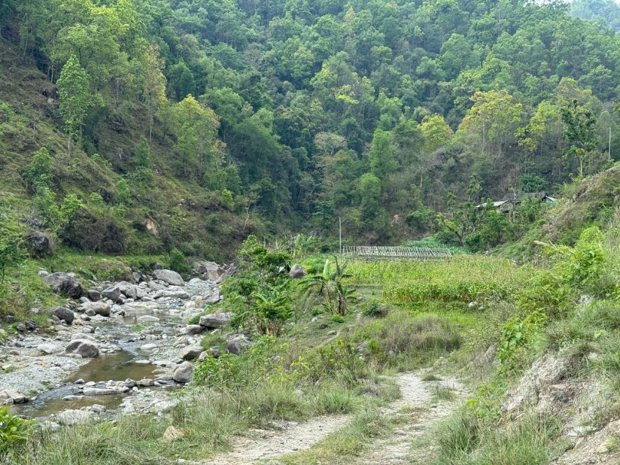
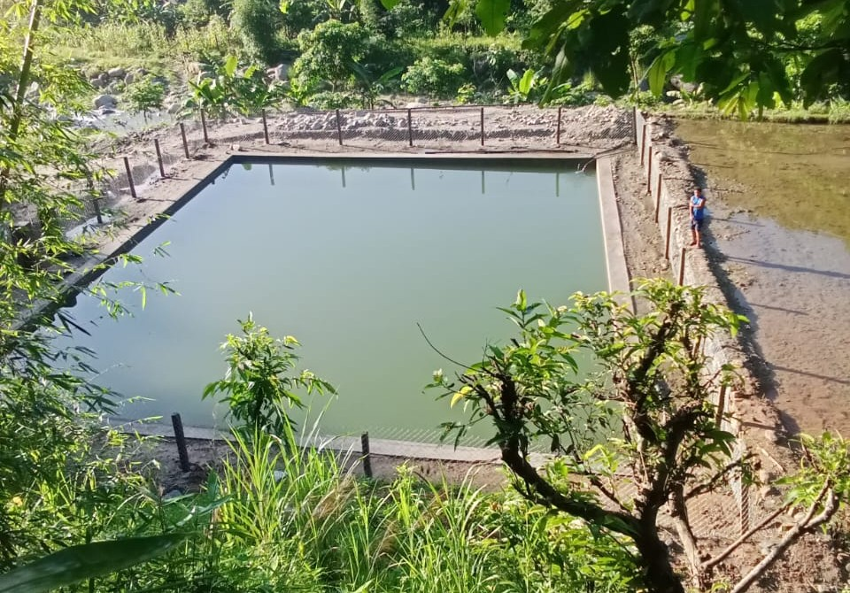
Before intervention
After intervention
PACKAGE INTERVENTIONS:
Physical infrastructure, Fingerling stocking, Community orientations, Greenery development
KEY RESULTS:
- Directly benefiting 1 household
- Combined water-holding capacity of 525 cubic meters
- Plantation on the surrounding of pond with species like Banana, Mulberry and local grasses.
- Enhance groundwater recharge and soil moisture, while supporting local livelihoods through fish farming, improving food security, and providing irrigation during dry periods to boost climate resilience.
SOCIAL AND ENVIRONMENTAL SAFEGUARDS:
- Free, Prior, and Informed Consent (FPIC)
- Protective fencing, Safety information
- Worker insurance during construction work

KEY FUTURE PLANS:
- Regular monitoring and coaching for maintenance
- Coaching and mentoring to link income generation and irrigation

FOR MORE INFORMATION & SUGGESTIONS:
Managing Watersheds for Enhanced Resilience of Communities to Climate Change in Nepal (MaWRiN) Project
Project Management Unit (PMU)
Kamalamai Municipality-6, Sindhuli, Nepal
Phone no. +977-47-590009
Email: mawrin.mofe@bagamati.gov.np
Website: https://mawrin.bagamati.gov.np
 |  | 

