A report on Result Based monitoring visit to fishery pond and progress monitoring of improved livestock shed

Background:

The MaWRiN project aims to support the government and local stakeholders in managing the Marin watershed while strengthening the long-term climate resilience of Indigenous peoples and local communities. The project’s objective is “to enhance the climate resilience of Indigenous people and local communities in the Marin watershed through nature-based solutions and livelihood diversification”.

A range of activities have been implemented under this initiative. Proper documentation and reporting of these efforts are essential to demonstrate the program’s outputs, outcomes, and impacts to donors and stakeholders. In this context, a field visit planned in the MaWRiN project areas on 19 March 2026. The visit focused on output level monitoring visits as well as providing necessary on-site support to ensure effective implementation of activities and to assess progress on the ground. The visit also aimed to evaluate interventions, identify challenges, and derive lessons for improving future program strategies.

Objectives of visit
The main objective of this monitoring visit was to enhance awareness of program interventions in the field and to gather feedback that contribute to the improvement of the program moving forward. In addition, the visit plans to assess and analyze the output level results, and discuss ground-level realities. These efforts aim to strengthen ongoing work and inform future strategies and actions.

Specific Objectives are following:
- To monitor the implementation and effectiveness of field activities.
- Status of Fishery Pond
- Marketing and Opportunities
- Coordination with GLAs
- Major issues and Challenges
- To provide recommendations for future intervention strategies, with a focus on program delivery, coordination, communication, and field monitoring.

Methodology:

The monitoring visit was conducted using a participatory approach. It will involve on-site visits to intervention areas, along with interactions with beneficiaries, community members, and other relevant stakeholders.
- Major Findings of Fishery Pond Development
The monitoring visit to the fishery pond sites in Ghagar and Kyan sub-watersheds revealed that the physical infrastructure of the ponds has been developed satisfactorily, and the overall environmental conditions are favorable for fish farming. However, there are several operational and management challenges that need to be addressed to ensure effective utilization and sustainability of the intervention.
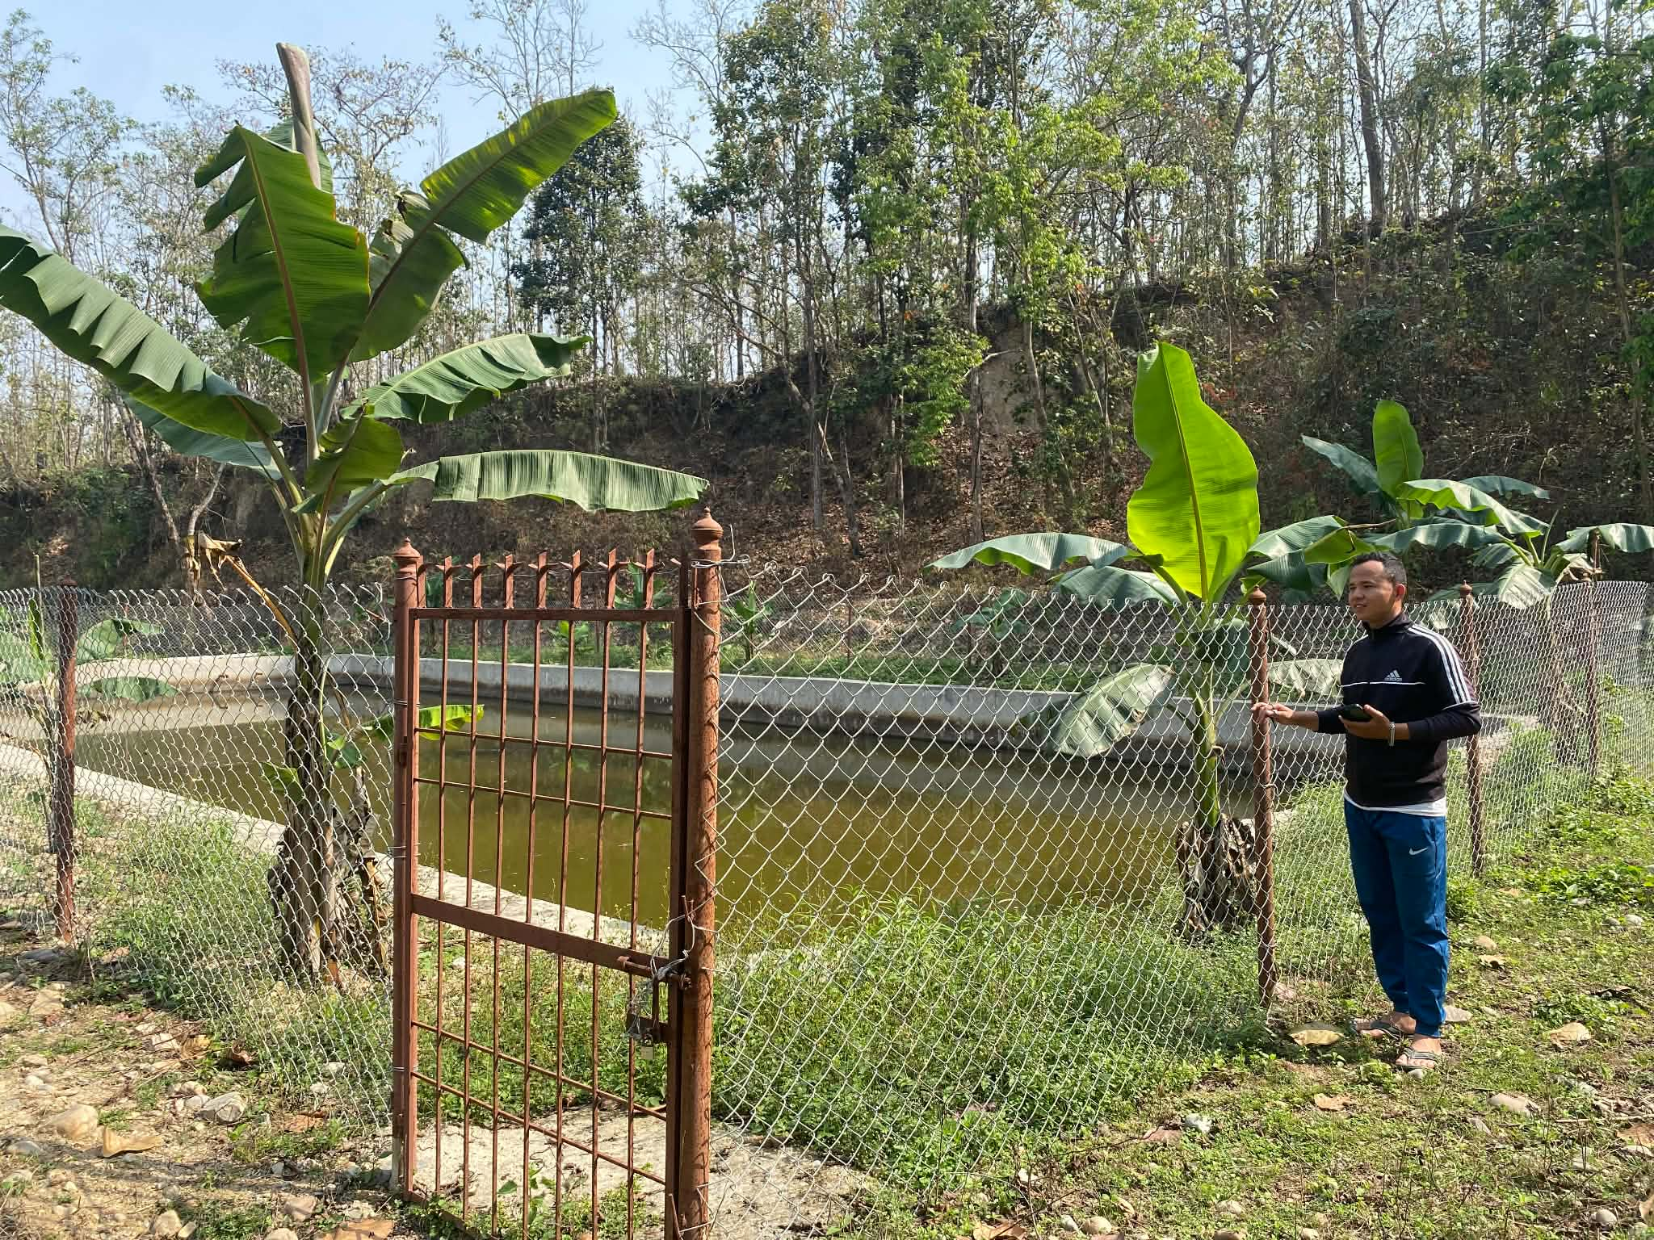
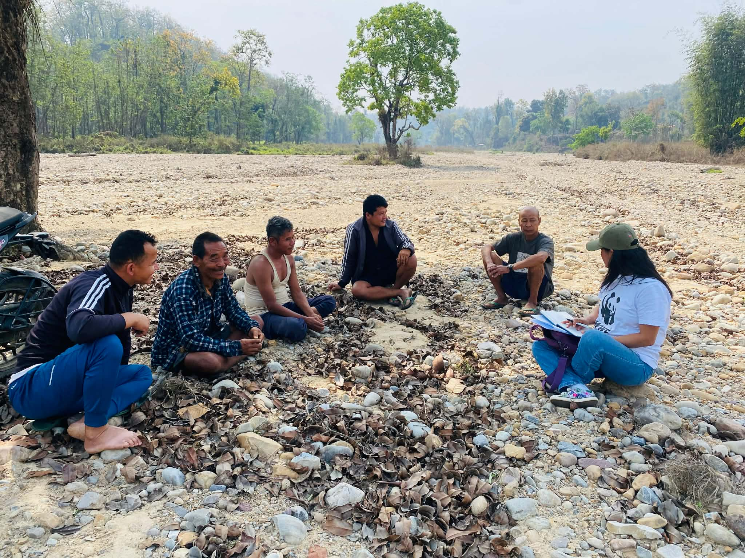
In the Ghagar sub-watershed, the fish pond was found to be well managed and in good condition. The plantation around the pond, including banana and kimbu seedlings, has grown well, indicating proper care and favorable environmental conditions. Water availability in the pond is sufficient, and both inlet and outlet systems are functioning effectively. Despite these positive conditions, no fingerlings were found in the pond during the visit. However, the presence of local fish species suggests that the pond environment is suitable for fish production. Community members reported that previously stocked fingerlings did not survive, which has affected the initiation of fish farming activities. Beneficiaries also expressed the need for continued support, particularly in terms of fish feed.
Figure 2:Fishery Pond development- Gangar sub-watershed (Chairperson of Sub-watershed)
Figure 1: Community interaction during monitoring visit to fishery pond development- Gangar Sub-Watershed
Regarding livelihood, the primary source of income for beneficiaries before the project was agriculture. Fish farming was introduced as an alternative income-generating activity; however, income generation has not yet started. This indicates the need for further technical support, improved management practices, and scaling of the intervention. Although beneficiaries have a positive perception of fish farming and its potential to improve their livelihoods, there is a noticeable lack of ownership and accountability. The pond is not managed by a specific individual or group, and most community members are engaged in their own activities. This has resulted in weak management of the pond. Therefore, it is essential to establish a clear management and ownership mechanism to ensure better results and sustained income generation.
In terms of capacity building, beneficiaries have received training, technical guidance, and inputs such as fingerlings, feed, and pond development support. Their knowledge of pond management, feeding practices, and basic fish farming techniques has improved. However, their capacity to manage fish farming at a commercial level is still developing and requires continuous technical support and follow-up. Although fish farming has good market potential, there are significant gaps in market linkage and value chain development. The absence of structured marketing systems limits the ability of beneficiaries to generate income from fish farming.
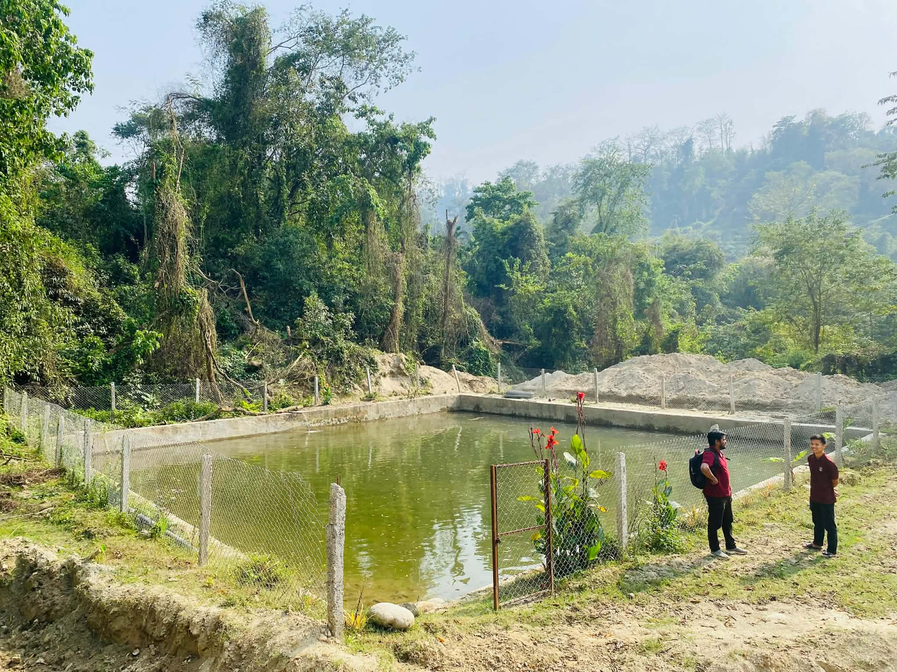
In the Kyan sub-watershed, similar observations were made. The fish pond is in good condition, and plantation activities, including flowers and banana, have been successfully survived. Water availability is sufficient; however, the outlet system still needs to be constructed to ensure proper water management. In addition, he reported that previously stocked fingerlings did not survive.
Figure 3 Fishery Pond Devolvement- Kyan Sub-Watershed
The primary livelihoods of beneficiaries include agriculture and teaching. Fish farming has been introduced as an alternative income source, but income generation has not yet begun. Despite this, the beneficiary has a positive outlook and has developed plans to enhance the use of the pond. These include creating a small irrigation system using pond water, initiating dragon fruit farming around the pond using support structures, and starting pig farming nearby. These plans indicate strong potential for integrated farming and livelihood diversification.
Capacity-building efforts in Kyan have been similar to those in Ghagar, with beneficiaries receiving training, technical guidance, and input support. While their knowledge of basic fish farming has improved, their capacity for commercial-level production remains limited and requires further strengthening. Marketing opportunities exist in Kyan as well, but similar challenges persist, including weak market linkages and the absence of a structured value chain. Additionally, both sites face common challenges such as the need for continuous technical support and risks to sustainability due to limited follow-up mechanisms.
Overall, while the fishery pond interventions have achieved good progress in terms of physical development and environmental suitability, fish production and income generation have not yet been realized. Addressing issues related to fingerling survival, strengthening management and ownership structures, improving technical support, and developing market linkages will be critical for ensuring the long-term success and sustainability of these interventions.
- Major Findings of Improved livestock shed:
During the monitoring visit, the progress of improved livestock shed construction was also observed in both the Ghagar and Kyan sub-watersheds. It was found that the construction of improved sheds is currently ongoing in both locations. The beneficiaries expressed their commitment to completing the construction within the planned timeframe.
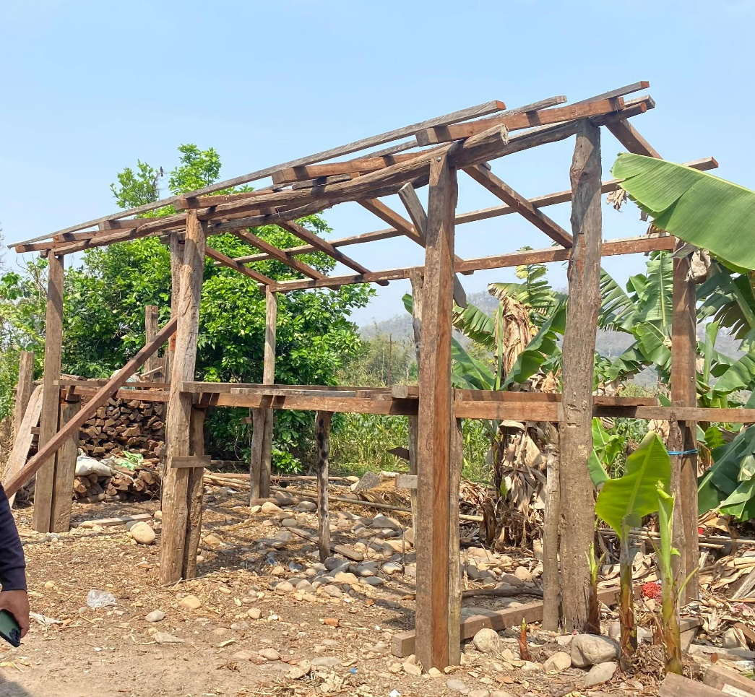
In the Ghagar sub-watershed, specific observations and feedback were gathered regarding the improved goat shed. Beneficiaries highlighted that the current design of the shed appears somewhat low in height, which may limit pro per air circulation. They noted that inadequate ventilation could negatively affect livestock health and productivity. In response to this concern, there is a plan to increase the height of the shed to ensure better airflow and create a more suitable environment for goat rearing.
Figure 4 Improved Goat shed- Gangar Sub-Watershed
Additionally, the beneficiaries suggested modifying the roof design. The existing plan includes a single-sided roof however, due to heavy seasonal rainfall in the area, this design may not be effective. Instead, a two-sided (gable) roof structure was recommended, as it would provide better protection against rain and improve durability. Based on this feedback, adjustments have been planned to incorporate a two-sided roof in the improved goat shed design.
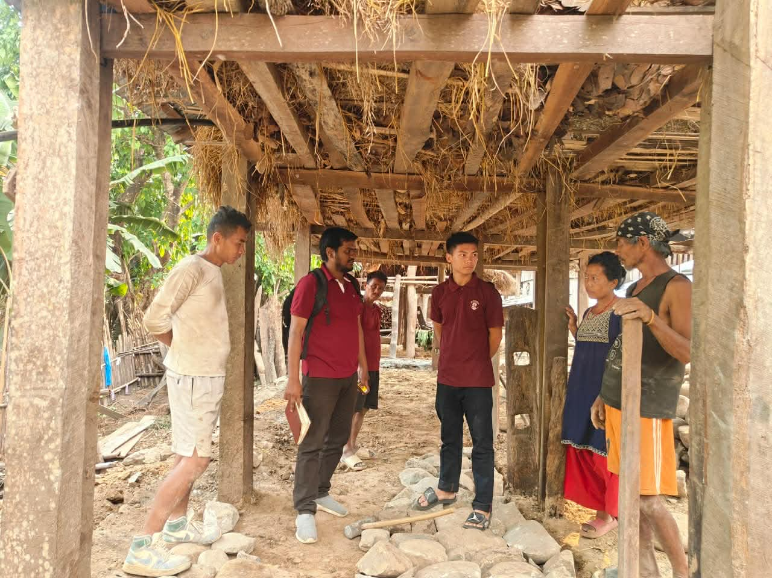
Similarly, in both sub-watersheds, the construction of improved cow/buffalo sheds is also in progress. Beneficiaries are implementing the construction in a rotational manner. At present, one shed has been completed, while another is still under construction. This phased approach is allowing beneficiaries to manage resources and labor effectively while ensuring gradual improvement of livestock housing conditions.
Figure 5 Improved Cow/Buffalo Shed- Kyan Sub- Watershed
Overall, the progress of improved livestock sheds is satisfactory, and the incorporation of beneficiary feedback into design modifications is a positive step toward ensuring functionality, sustainability, and improved livestock productivity
- Conclusion:
The monitoring visit to the Ghagar and Kyan sub-watersheds indicates that significant progress has been made in the physical development of fishery ponds and improved livestock sheds. The environmental conditions of the ponds are suitable, and plantation activities around the sites are well established. However, fish production and income generation have not yet been realized due to challenges such as fingerling survival, weak management systems, and limited technical follow-up.
Beneficiaries have shown a positive attitude toward the interventions and demonstrated interest in expanding livelihood options through integrated farming practices. At the same time, gaps remain in ownership, market linkage, and technical capacity, which are critical for achieving sustainable outcomes. The ongoing construction of improved livestock sheds reflects good progress, and the incorporation of beneficiary feedback into design improvements is a positive step toward enhancing functionality and resilience.
Overall, the interventions have strong potential to contribute to livelihood diversification and climate resilience. With strengthened technical support, improved management mechanisms, enhanced market systems, and continuous follow-up, these initiatives can generate sustainable income and long-term benefits for local communities.
- Recommendation:
Based on the field observations and interactions in both Ghagar and Kyan sub-watersheds, the following recommendations are proposed:
7.1 Fishery Pond Development:
- Provide immediate technical support to address fingerling survival issues, including water quality management and proper stocking techniques.
- Ensure timely supply of quality fingerlings and fish feed to restart fish farming activities.
- Conduct refresher training on pond management, feeding, and disease control.
- Establish a clear ownership and management mechanism (individual or group-based) for fish ponds to ensure accountability.
- Develop simple operation and maintenance plans for each pond.
- Facilitate market linkage development for fish products through local traders, cooperatives, or collection centers.
- Promote value chain development and collective marketing systems.
- Support beneficiaries in identifying local demand and pricing mechanisms
- Promote integrated farming systems (fish + livestock + horticulture), as seen in Kyan (e.g., dragon fruit, pig farming, irrigation use).
- Provide technical guidance on optimizing multiple income sources from the same land resource.
- Strengthen women’s involvement in decision-making and financial roles.

7.2 Livestock Shed Improvement
- Revise shed designs to ensure:
  - Adequate height and ventilation for better air circulation
  - Two-sided roofing structure to withstand heavy seasonal rainfall
  - Provide technical supervision to ensure quality construction standards.
- Encourage reinvestment by beneficiaries to scale up production.
- Expand the intervention to more households to increase impact.

Itinerary:

S. N | Sub-Watershed | Activities | Remarks | Team
1 | Ghagar Sub-Watershed | Fishery development as a physical barrier to flooding | KII, FGD, Site Visit | Sanu
 |  | Improved livestock shed | Site Visit, KII, | Sanu
2 | Kyan Sub-Watershed | Fishery development as a physical barrier to flooding | KII, FGD, Site Visit | Sanu, Praful
 |  | Improved livestock shed | Site Visit, KII, | Sanu, Praful

Details Data
Name of Sub/Watershed (Only FW Funding) | Type of Supports | Length m | Breadth m | Height m | Total Area Protected(Ha) | Janjati HHs(No.) | Total Beneficiary HHs(No.) | Male Employed (No.) | Male (Person-hours) | Female Employed (No.) | Female (Person-hours) | Total Leveraging (NPR) | Remarks | Poor HHs(No.) | Total HHS(No.)
Ghagar Sub-watershed | Pond construction, Orientation, Fencing, Plantation, Fingerlings stocking, Hoarding board | 33 | 13 | 1.5 | 0.0429 | 1 | 1 | 23 | 2776 | 10 | 1232 | 11383 | Fingerlings 720; Pond size 16 m*33 m; Fencing 108 m; Plantation 150 seedlings; Hoarding boards installation | 1 | 1
Kyan Sub-watershed | Pond construction, Orientation, Fencing, Plantation, Fingerlings stocking, Hoarding board | 20 | 20 | 1.5 | 0.04 | 1 | 1 | 18 | 2104 |  | 0 | 11171 | Fingerlings 600;  Pond size 20 m*20 m; fencing 106 m, Plantation 150 seedlings; Hoarding boards installation | 1 | 1

